**Belief in the community**

In this unit of work the children will explore patterns in our lives, contrasting them with those of people of faith.

They will also consider how personal beliefs affect your way of life, and how symbols and artefacts play an important part in rites of passage.

**Key Vocabulary**

faith family

belonging

festivals

artefacts

symbols

celebration

commitment

shared values

holy books

remembrance

rituals

reflect

differences

similarities

identity

**In this unit children will:**

* Explore religious stories that identify how believers are expected to behave
* Understand the significance and use of symbols and artefacts in rites of passage
* Consider what it means to belong to a group
* Find out why group sessions often involve rituals
* Consider significant moments in pupils’ lives and what symbols might be associated with these
* Understand why certain clothing is worn, artefacts used and symbols seen in ceremonies and rituals, and their importance to a faith member

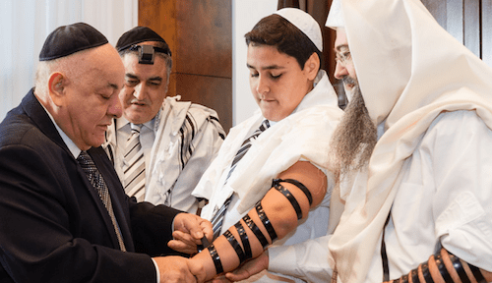

**Prior Learning**

**Year 1** 1.1 Looking at me

**Year 2**  2.1 Belonging

**Year 3**  3.2 Faith founders

**Cross Curricular Links**

**PSHE** Cultural awareness

**Key Knowledge**

* Many people of faith find that festivals and special celebrations help them to feel a sense of belonging.
* People of faith make ‘big promises’ and commitments during rites of passage.
* What a person believes influences the way they lead their lives.
* For a person of faith, the key teachings from their holy book shape their values.
* People of faith wear and use symbols and artefacts to reflect their beliefs.

**Key Questions**

* What does it mean to belong?
* Where do people get their sense of identity?
* How does a set of beliefs provide a code for living?
* What freedom of choice does a believer have?
* Why do people of faith wear certain artefacts and carry out certain rituals?
* Why does it matter to a believer to be married in their place of worship?

