Hedon Primary School | COVID-19 - COVID Prevention (Schools) Full Reopening Safe System of Work (8th March 2021v1)
Date of Assessment: 2/3/2021 | Name of School Assessor: Amanda Barnett
There has been a requirement to have in place a COVID safe system of work from the outset of the pandemic. Throughout this time schools have remained open and we have learned lessons and adapted our approach to reflect national guidance and advice from our local Public Health team.

This safe system of work has now been reviewed in response to the announcement of full reopening of schools from 8th March 2021.

It should be noted that specific guidance on out of school settings, which many schools operate, is in place with details of provision which can be offered at each phase of the national roadmap:

https://www.gov.uk/government/publications/protective-measures-for-holiday-or-after-school-clubs-and-other-out-of-school-settings-for-children-during-the-coronavirus-covid-19-outbreak/protective-measures-for-out-of-school-settings-during-the-coronavirus-covid-19-outbreak

Special Schools are recommended to consider guidance and ensure specific controls are incorporated into their own risk assessment:

https://www.gov.uk/government/publications/guidance-for-full-opening-special-schools-and-other-specialist-settings

The system of controls provides a set of principles and if schools follow this advice, they will effectively minimise risks. All elements of the system of controls are essential. All schools must cover them all, but the way different schools implement some of the requirements will differ based on their individual circumstances.

This model safe system of work should therefore be adapted to suit the specific arrangements in place at your school.

Schools must continue to regularly review their own control measures, discussing with staff and recording any revisions to arrangements. Any changes must be communicated as necessary.

Risk assessments should be uploaded to school websites to ensure ongoing communication with stakeholders.

The following are the system of prevention of controls.

Schools must always implement the following:

- Minimise contact with individuals who required to self-isolate by ensuring they do not attend school. This applies to staff, students and visitors.
- Ensure face coverings are worn in recommended circumstances
- Hand hygiene – ensure everyone is cleaning their hands thoroughly and more frequently than usual
- Respiratory hygiene - Catch It, Bin It, Kill It approach to coughs and sneezes for everyone
- Maintain enhanced cleaning arrangements, particularly of frequently touched surfaces or shared spaces
- Consider how to minimise contact between individuals across the site and maintain social distancing wherever possible.
- Always keep occupied spaces well ventilated

In specific circumstances schools should:

- Ensure individuals wear the appropriate personal protective equipment (PPE) where appropriate
- Promote and engage in asymptomatic testing, where available

Prevention
It remains the case that any individual who meets any of the following criteria must stay at home and self-isolate in line with national requirements:

- They, someone they live, or member of their support bubble have symptoms, of COVID-19
- They or someone they live with receives a positive LFD Test result, or is awaiting results from a PCR Test.
- They, someone they live with, or a member of their childcare or support bubble has tested positive through a PCR test
- They have been instructed by NHS Track and Trace or the Local Public Health Team, to self-isolate
- They are awaiting COVID-19 test results
- On return from abroad, where applicable

They must not attend the school.

This must be reiterated through communication with staff and parents

Any members of staff who have helped someone with symptoms and any pupils who have been in close contact with them do not need to go home to self-isolate unless they develop symptoms themselves (in which case, they should arrange a test) or if the symptomatic person subsequently tests positive (see below) or they have been requested to do so by NHS Test & Trace.

National guidance must be followed (see link below):

Guidance for Households with Possible or Confirmed Coronavirus (COVID-19) Infection

Schools are permitted to refuse access to any individual who is displaying symptoms but who cannot confirm a negative test.

Visitors
Adult visitors to all settings must wear a face covering when moving around the school site, and at all times unless social distancing can be strictly maintained. This includes when moving around through corridors or communal areas, and working in classrooms. This does not apply to individuals who have an exemption. Face coverings may be removed to eat and drink, or participate in strenuous activity, such as PE lessons.

Wherever possible we must accommodate visits that support the health and wellbeing of children, or the safe operation of the school site, but these should be kept to a minimum and safe systems must be discussed in advance. Visits must therefore be by appointment only, and kept to a minimum. Wherever possible visits should be held out of school operating hours.

Social distancing must be strictly adhered to during visits. Whilst external professionals (such as supply staff) may work across bubbles this should be an exception and not the rule. Strict safe systems of work must be followed.

Schools must continue to work with, and accommodate, healthcare services to ensure continued progression of healthcare programmes such as screening and immunisation. Safe systems of work must be applied and schools are therefore recommended to discuss expectations with the healthcare provider to reach a safe and practical solution.

The LA have a safe system of work in place which council employees must adhere to as a visitor to your school.

All visitors who access the site must be requested to read and sign the Visitors Agreement. Contact Details must be obtained for Track and Trace purposes. Volunteers and Supply Staff must also be provided with a copy of the schools COVID Prevention Safe System of Work.

Any individual who does not sign the Visitors Agreement may not be permitted access to the school.
- If you have observed that there are pinch points during drop off/collection or that social distancing is not being adhered to by parents, you may wish to strongly encourage parents/carers to wear face coverings at these times even when outdoors
- Arrange staggered start and finish times for bubbles to avoid large gatherings of parents on the school site
- Request that children are dropped off and collected by one parent only, and do not enter the building when doing so
- Put up signage to remind parents where to drop off and pick up – communicate this in advance
- Continue to promote the use of electronic payment wherever possible
- Arrange appointments for contractors, parents and other visitors on a needs-must basis only, our of hours if possible.
- Ensure the visitor has a face covering and that this is worn for the duration of their visit.
- Visitors should bring minimal personal belongings in to school.
- Identify an appropriate room for visits to take place. Outdoor space should be utilised wherever possible. Ensure furniture is arranged to allow for social distancing and that the room is well ventilated.
- Provide a ‘Disinfection and Hygiene Station’ in each room available to visitors, including tissues, hand sanitiser, disinfectant spray, disposable paper towels/cleaning material and a bin.
- Plan visits so that the number of ‘bubbles’ they visit is minimised
- Visitors must wash hands thoroughly, frequently and between moving groups or activities
- Ensure that social distancing (2 metres) is implemented during any visits
- Visitors must wear a face covering within the school building (unless an exemption applies)
- Monitor compliance by visitors. Increase the frequency and content of communications as appropriate.
- Visitors should consider changing clothes prior to working in another ‘bubble’ if clothing has been contaminated by bodily fluids.
- If a dedicated room has been used to facilitate the visit, ensure it is thoroughly cleaned and remains well ventilated after the visit has been vacated

Potential Hazards and Injuries:  - Transmission of COVID-19 within school and in the wider community due to failure to adhere to public health guidance  - Long term health implications for children if healthcare services are not continued  Who Might be Affected:  - Staff  - Students  - Supply Staff  - Contractors  - Health and Educational Professionals  - Visitors  - Volunteers  - General Public | Do:  Communicate with parents and use signage to reinforce messages  Arrange appointments with visitors and only allow access where necessary.  Ensure all prevention measures are adhered to by visitors  Obtain names and contact details of all visitors, and request that they sign the visitors agreement  Use alternative means of communication wherever possible. For Example phone calls, Microsoft Teams | Don’t:  X Allow access the school building if someone has symptoms of COVID-19  X Allow groups of parents to congregate  X Allow visitors on site if prevention measures cannot be followed  X Allow visitors to enter the school site without a face covering

Infection Control
In secondary settings face coverings should be worn by adults and pupils when moving around the premises, outside of classrooms, such as in corridors and communal areas where social distancing cannot easily be maintained. Face coverings do not need to be worn by pupils when outdoors on the premises.
In addition face coverings should be worn in classrooms or during activities unless social distancing can be maintained.

This does not apply in situations where wearing a face covering would impact on the ability to take part in exercise or strenuous activity, for example in PE lessons.

In primary and nursery settings, face coverings should be worn by staff and adult visitors in situations where social distancing between adults is not possible (for example, when moving around in corridors and communal areas). Children in primary and nursery settings do not need to wear a face covering.

Visors alone must not be worn as an alternative to face coverings. Face coverings must be worn in recommended circumstances unless the individual has a recognised exemption, and schools must be sensitive to those needs.

You should regularly remind students and staff of how to wear, store and dispose of face coverings. Parents/carers will need to be informed of the need to supply their children with sufficient, clean face coverings.

https://www.gov.uk/government/publications/face-coverings-in-education/face-coverings-in-education#:~:text=Nationwide%2C%20the%20government%20is%20not,environments%2C%20provides%20additional%20mitigating%20measures.

Students travelling on school transport are required to wear a face covering whilst on board. The school must provide facilities for students to dispose of face masks (if applicable) and to clean hands on arrival at school.

- Display posters which support the key messages of infection control prominently throughout the school site.

- Access to handwashing facilities OR hand sanitiser should be available at all times, throughout the school, including in toilets and each classroom if possible. Cleaning hands must be done more frequently and thoroughly than usual, including (but not limited to) upon arrival at school, before and after eating and after coughing or sneezing, and frequently throughout the day. Soap and water is preferable before eating. Hand sanitiser must include a minimum alcohol content of 60%. For younger children, skin friendly cleaning wipes are an acceptable alternative.

- Prepare a ‘Disinfection & Hygiene Station’ within each classroom with access to disposable towels and disinfectant spray, tissues and hand sanitiser to allow teaching staff to regularly sanitise as required.

- Consider the use of shared staff equipment such as photocopiers, telephones or kitchen appliances. Cleaning supplies must be available for use in between individuals. Make staff aware of the need to clean before using and make this is as easy as possible by making cleaning supplies accessible.

- Tissues should be readily available at all times in classrooms for good respiratory hygiene. Everyone should be regularly reminded to use a tissue or their sleeve to capture droplets. Hands must be washed after coughing or sneezing – staff should monitor children doing this within their bubble where applicable.

- Ensure bins are available in each classroom and other key locations to encourage ‘catch it, bin it, kill it.’

- Request parents provide their children with a pencil case and writing equipment OR provide equipment to be allocated to each child to avoid sharing

- Ensure that any resources (such as toys or books) are allocated to a specific bubble. If you cannot clean, quarantine. If books are sent home with children, or for children who are receiving remote education the guidance below regarding cleaning and quarantine must be followed.

- Ensure that any resources that a shared across bubbles are cleaned meticulously and frequently, and ALWAYS between each bubble. If items cannot be cleaned provision must be made to ensure that the resources are ‘quarantined’ for a period of 48 hours (or 72 hours if plastic) prior to being used another bubble.

- Prepare a cleaning regime that includes shared spaces (such as toilets and kitchens), regularly touched surfaces (such as door handles, banister rails, light switches, hand dryer buttons, the kitchen servery, etc) and equipment (sports equipment, IT equipment). The cleaning solution must be a combined detergent disinfectant and ideally be completed using disposable cloths or wipes. Cleaning must be in accordance with government guidance and a dedicated safe system of work is available to support this.

- Allocate specific toilets or cubicles to each bubble and staff if possible – If this is not possible ensure an enhanced cleaning regime is in place. You may wish to consider asking students to sanitise their hands when they return to the classroom to ensure cleaning of hands can be supervised.

- Inform parents that they must limit the amount of equipment that children bring in to school each day. Resources can be sent home but hand hygiene rules must be followed when handling the items. They should be cleaned or quarantined upon their return if they are going to be used by another bubble.
Potential Hazards and Injuries:  - Contact with bodily fluids, droplets and airborne transmission leading to transmission of COVID-19 within school and in the wider community due to failure to adhere to public health guidance  Who Might be Affected:  - Staff  - Contracted staff  - Students  - Supply Staff  - Health and Educational Professionals  - Visitors | Do:  Clean hands frequently and thoroughly throughout the day  Maintain an enhanced cleaning regime which includes frequently touched surfaces and shared spaces or equipment  Ensure bins are emptied regularly  Ensure that face coverings are worn in recommended circumstances, being sensitive to the needs of those who cannot wear one due to valid exemption | Don’t:  X Use equipment or toys that cannot be easily cleaned (such as trim trail, soft toys, textiles, playdough or equipment with intricate parts) unless these are allocated to a specific bubble only  X Allow children to bring anything more than the minimum amount of equipment from home (lunch box, coat, bag, book, stationary and mobile phone, face covering)  X Allow shared use of resources or rooms across bubbles without cleaning or quarantining before further use

Minimising Contact and Social Distancing
- Maintain consistent bubbles and maintain records of who these comprise. It is important to remember that bubbles do not just apply to students, they apply to staff too.
- Each distinct bubble should maintain distance with all other school bubbles through staggered arrival, staggered break and lunch times, and staggered end times. Maintain timetables so this can be shared with staff and parents as applicable.
- In secondary schools lesson start and finish times must be considered to ensure there is minimal mixing of class groups or consider locating bubbles in a dedicated classroom and teachers move around the school, rather than children moving to different classrooms (taking in to account safeguarding and supervision requirements).
- Continue to arrange classrooms to facilitate distance between desks, front facing and side by side where possible. Furniture may need to be removed or re-positioned to facilitate this.
- A ‘teacher zone’ must be implemented in each classroom to ensure the teachers can remain 2metres away from children as much as possible.
- Implement a one-way or ‘keep left’ arrangement in corridors
- Events, such as assemblies, collective worship or staff meetings) involving multiple school class groups (staff or students) or other schools must not be planned or take place.
- Make use of outdoors for activities as much as possible
- Staff must maintain 2 metres distance from colleagues. Use of staff rooms must be minimised. Staff rooms may have to be restricted to a maximum number of users, with seating at least 2 metres apart, and be well ventilated, with cleaning supplies readily accessible. Staff must clean appliances, cutlery, etc and surfaces after personal use.
- Staff must maintain 2 metres distancing from one another. All staff must reduce the number of contacts, the duration of contact, and the frequency of contact across the school day. Exceptions may include when administering first aid to another member of staff, or to provide support during interventions with a child. Details of any cumulative contact beyond 15 minutes with another individual outside of their bubble must be noted.
- Make use of electronic communication to staff and parents
- Mock Exams must not take place with a mix of bubbles in one room, such as a hall. Consider the use of classrooms for mock exams to take place under exam conditions, with bubbles maintaining their integrity and existing prevention measures in place.
- Singing activities can take place as a bubble only. The room must be well ventilated, or preferably take place outdoors. Children should ideally be spaced 2 metres apart, facing forwards and positioned side-by-side. Teaching staff must be 3 metres away from the front of the class. Background music should not be too loud as this may encourage louder singing.
- Car-sharing must be discouraged unless safety measures are strictly in place. This includes opening car windows, wearing of face coverings and ensuring regular cleaning of touch points such as door handles, handbrake, steering wheel, seat belt buckle, etc.

Potential Hazards and Injuries:  - Contact with bodily fluids, droplets and airborne transmission leading to transmission of COVID-19 within school and in the wider community due to failure to adhere to public health guidance  - Spread of infection due to poor practices.  Who Might be Affected:  - Staff  - Contracted staff  - Students  - Supply Staff | Do:  Maintain distinct ’bubbles’ comprising identified staff and children who do not mix with other bubbles  Remove any unnecessary furniture to facilitate improved distancing, including implementation of a ‘Teacher Zone’ to ensure 2 metres distance wherever possible  Implement a one way or ‘keep left’ arrangement in corridors | Don’t:  X Have face-to-face contact and minimise time spent within 2 metres of anyone else  X Complete activities which involve bubbles mixing, or close contact (such as assemblies, contact sports, mock exams or school events.)  X Compromise supervision levels, but do use the fewest number of staff as possible to a bubble to ensure safety  X Forget to use electronic communication rather than face-to-face where possible  X Do not allow gatherings of staff from across bubbles

Asymptomatic Testing
The purpose of Lateral Flow Device Testing is to support in identifying asymptomatic cases to reduce the transmission of COVID-19 within the school, and wider, community. Schools therefore continue to play an important, and ever evolving, role in saving lives.
Lateral Flow Device Testing will be provided to all staff in all settings on a twice-weekly basis. In special schools, secondary schools and alternative provision settings students will also be offered routine testing. Participation is voluntary, though is strongly encouraged.
Details of the LFD home testing, including ‘how to guides,’ training videos and templates can be found at the following link:

https://drive.google.com/drive/folders/1X4fLxy6_ppmpmKrv3hT2M6cduAN_GS54

Individuals who have symptoms of COVID-19 must book a Polymerase Chain Reactions (PCR) test. LFD Testing is not appropriate for symptomatic individuals. Individuals with symptoms can book a test online at the link below, or by calling NHS 119.
https://www.nhs.uk/conditions/coronavirus-covid-19/testing-and-tracing/
Individuals who return a positive result on an LFD test must self-isolate immediately along with their household, and arrange for a confirmatory PCR test.
Asymptomatic testing does not replace the robust system of controls – it is an element of number one of the prevention system of controls – minimising contact with individuals who are required to self-isolate.
Staff must be regularly reminded of the need to comply with all prevention measures all of the time to ensure transmission risk is reduced.
A dedicated risk assessment for COVID-19 Home Testing is available and must be shared with all participating staff.

- Schools must identify appropriate individuals to fulfil the required testing roles in line with the ‘How to Guides’
- Consent must be obtained from all participants of the testing programme
- Schools must ensure that COVID safe arrangements are in place to facilitate safe collection of testing kits, in line with the dedicated risk assessment
- All participants of the testing must be made aware of instructional videos and guidance. These must be followed.
- Staff must be provided with the dedicated risk assessment to ensure that are made aware of specific hazards and the measures in place to ensure a safe and effective testing process
- Participating staff must ensure that results are returned the school in a timely manner. Schools must have a system to record all results, including voids.
- Incident management arrangements must be in place and staff must report all incidents, however minor, in line with the dedicated home testing risk assessment.

Premises
- Ensure that spaces can be ventilated. This can be achieved by a variety of measures including:
- Mechanical ventilation systems – these should be adjusted to increase the ventilation rate wherever possible, and checked to confirm that normal operation meets current guidance (if possible, systems should be adjusted to full fresh air or, if not, then systems should be operated as normal as long as they are within a single room and supplemented by an outdoor air supply)
- Natural ventilation – opening windows (in cooler weather windows should be opened just enough to provide constant background ventilation, and opened more fully during breaks to purge the air in the space). Opening internal doors can also assist with creating a throughput of air (as long as they are not fire doors and where safe to do so). If necessary external opening doors may also be used (taking in to account safeguarding and security arrangements.)

- Thermal comfort must not be compromised. Heating can, and should, be used as necessary in occupied spaces.
- Furniture may need to be rearranged to reduce direct draughts.
- Communicate to staff and parents that in order to reduce the risk of COVID transmission, ventilation will need to be increased. Staff and students may therefore wear additional and suitable indoor clothing.
- Ensure walkways are unobstructed – remove furniture or anything that creates ‘pinch points’
- Display posters throughout the school to reinforce key messages – Hand Hygiene, Catch It, Bin It, Kill It and Maintain Distance
- Ensure all building checks are maintained, including legionella and fire.
- Ensure emergency evacuation procedures are reviewed to facilitate minimal contact. For example, at the assembly point ensure bubbles are positioned 2 metres from one another. Continue to complete fire drills at least termly.
- Use external doors for access and egress to classrooms if possible
- Monitor the site to ensure walkways remain clear and unobstructed
- Ensure that enhanced cleaning arrangements are completed throughout the day in line with the dedicated safe system of work, paying particular attention to shared spaces (such as bathrooms, kitchens, dining halls or classrooms shared by different bubbles) and frequently touched surfaces (such as door handles/plates, banister rails, light switches. You may wish to consider devising a checklist and making record to verify that cleaning has been completed.

NOTE: Guidance on operating heating systems has been provided by ERYC. If you have queries or concerns regarding your heating or ventilation systems, please contact Building Facilities.

Potential Hazards and Injuries:  - Contact with bodily fluids, droplets and airborne transmission leading to transmission of COVID-19 within school and in the wider community due to failure to adhere to public health guidance  - Failure to maintain a safe site or comply with legislative requirements relating to the workplace  Who Might be Affected:  - Staff  - Contracted staff  - Students  - Supply Staff  - Contractors  - Visitors  - General Public | Do:  Devise a documented cleaning regime to ensure consistency and for monitoring purposes  Keep the school ventilated in line with guidance  Use external doors for access and egress where possible – ensure they are fixed open so as not to slam shut  Maintain safe and unobstructed movement around school | Don’t:  X Allow walkways to become cluttered or obstructed  X Wedge internal fire doors open if possible. Use hold-open devices if fitted.  X Compromise thermal comfort – use heating to ensure comfort levels are maintained

Staff Wellbeing

Preparing for the Task:

- Complete ongoing reviews of Individual Health Assessments for High Risk Employees with staff who are clinically vulnerable, clinically extremely vulnerable, BAME staff or those who are living with a clinically extremely vulnerable individual. Discuss their individual concerns, make a record of support measures to be implemented, and maintain regular communication with them.
- Consider training identified staff in COVID-19 Psychological First Aid. A free course is available at the following link:
https://www.futurelearn.com/courses/psychological-first-aid-covid-19/1
- Plan and agree staff expectations, workload and flexible working arrangements to support and reassure staff
- Familiarise yourself with support measures, such as the Employee Assistance Programme, available through BHSF or The Education Support Partnership, so you can share this with staff.
- Timetable regular breaks for staff and PPA time for staff. Staff are able to move across bubbles providing 2 metres distance is maintained between them and the children so use all available staffing resources.
- Ensure staff welfare arrangements are in place and they are included on a regular cleaning regime
- Refer to the DfE School Workload Reduction Toolkit to support managing work demands on staff.
- Monitor one another’s wellbeing and seek advice and support where necessary
- Keep in touch with one another, including those who are working from home
- Regular monitor ‘High Risk Employees’ to ensure that control measures agreed upon remain suitable and sufficient.

Potential Hazards and Injuries:  - Compromised mental health and wellbeing.  - Social isolation.  - Fatigue.  - Adverse impact on work life balance.  Who Might be Affected:  - Staff | Do:  Complete an Individual Assessment for High Risk Employees  Maintain communication, through for example MS Teams, WhatApp Groups  Access online wellbeing support if necessary through the Employee Assistance Programme (BHSF) or The Education Support Partnership  Take regular breaks  Seek advice from colleagues within the Local Authority at the earliest opportunity | Don’t:  X Suffer in silence  X Be afraid to ask for help and support.

Personal Care Activities where a child presents NO symptoms (such as toileting, supporting with managing medical conditions, first aid, etc)

There is no need for additional PPE over and above standard infection control procedures. PPE must only be used for one activity before being discarded appropriately.

In an emergency, call 999 if someone is seriously ill or injured, or their life is at risk
Specific guidance has been produced for settings where aerosol generating procedures have been identified as taking place.

Personal Protective Equipment:

Disposable Gloves

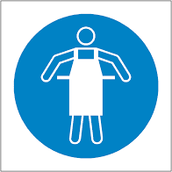
Disposable Apron*

*If there is likely contact with blood and/or bodily fluids as part of the activity.

Preparing for the Task:
- Clean hands thoroughly using soap and water
- Put on the required PPE as above

Completing and Finishing Task:
- Deliver care in adherence with your infection control guidance and training, and health care plan if applicable.
- Remove and double bag PPE in the immediate area
- Any contaminated clothing should be double bagged and securely stored until it is sent home with the child for washing.
- Hands MUST be washed using soap and water immediately after removing PPE
- Door handles and surfaces must be cleaned before entering and leaving the affected area.
- Thoroughly wash all your clothing as soon as you arrive home at the end of a day. Avoid shaking clothing before placing in the washing machine.
- Vehicles should be decontaminated frequently. Sanitiser should be used to clean down seats, gear sticks, steering wheel, door handles, etc.

Potential Hazards and Injuries:  - Contact with bodily fluids, droplets and airborne transmission leading to transmission of COVID-19  - Unpredictable behaviours leading to scratches and bites etc.  - Failure to respond to child’s injury or health care need, leading to acute or chronic health implications | Do:  - Wear appropriate clothing.  - Wear appropriate PPE.  - Maintain good hygiene and infection control standards.  - Regularly wash your hands | Don’t:  - Deliver care without wearing PPE.  - Use the same PPE for more than one task.  - Touch your eyes, nose and mouth.  - Consume food and drink until you have removed all PPE and washed your hands.

Procedure for Dealing with Symptomatic Individual
Should a child start to display symptoms whilst at school then they must be isolated in a separate, self-contained and ventilated room away from others or ensure they are situated 2 metres from others if isolation is not possible. If they require use of a bathroom whilst awaiting collection they should use separate facilities if possible, which should be thoroughly cleaned and disinfected before being used by anyone else.
999 must be called in the event of emergency, such as becoming seriously unwell or injured. Symptomatic individuals must not otherwise be advised to attend their GP, pharmacy, urgent care centre or hospital. They should be advised return home immediately, have a COVID-19 test as soon as possible and isolate whilst awaiting results.
To support the schools reporting protocols, results of the test must be communicated to the school.
Specific PPE requirements are recommended when caring for a symptomatic individual within close proximity (ie less than 2 metres.) New PPE must be worn and discarded of upon completion of the care.

Personal Protective Equipment:

Disposable Gloves

Disposable Apron
Disposable Fluid Resistant Face Mask (Surgical Face Mask)
Eye protection where contact is within 2 metres (either goggles or a face visor)

Preparing for the Task:
- Wash hands thoroughly following hand hygiene regime.
- Put on all the required PPE BEFORE entering the isolation area. You may wish to consider placing PPE and hygiene supplies outside of the dedicated room for ease.

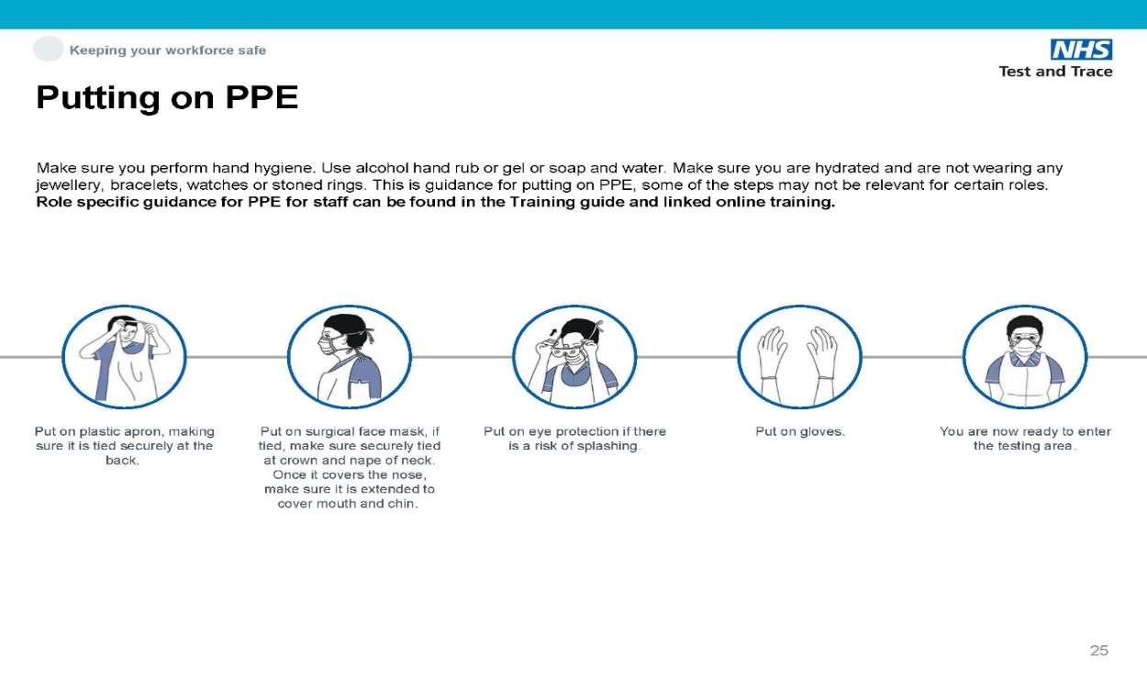

- Ensure the room is as well ventilated as possible.

Completing and Finishing Task:

- Deliver care in adherence with your infection control guidance and training, and health care plan if applicable.
- Any contaminated clothing should be double bagged and securely stored until it is sent home with the child for washing.
- On completion of the task, step outside the room and immediately remove the PPE. This and any soiled items MUST be double bagged in disposable rubbish bags and securely tied and left in a designated room for 72 hours before being disposed of in the usual waste stream.
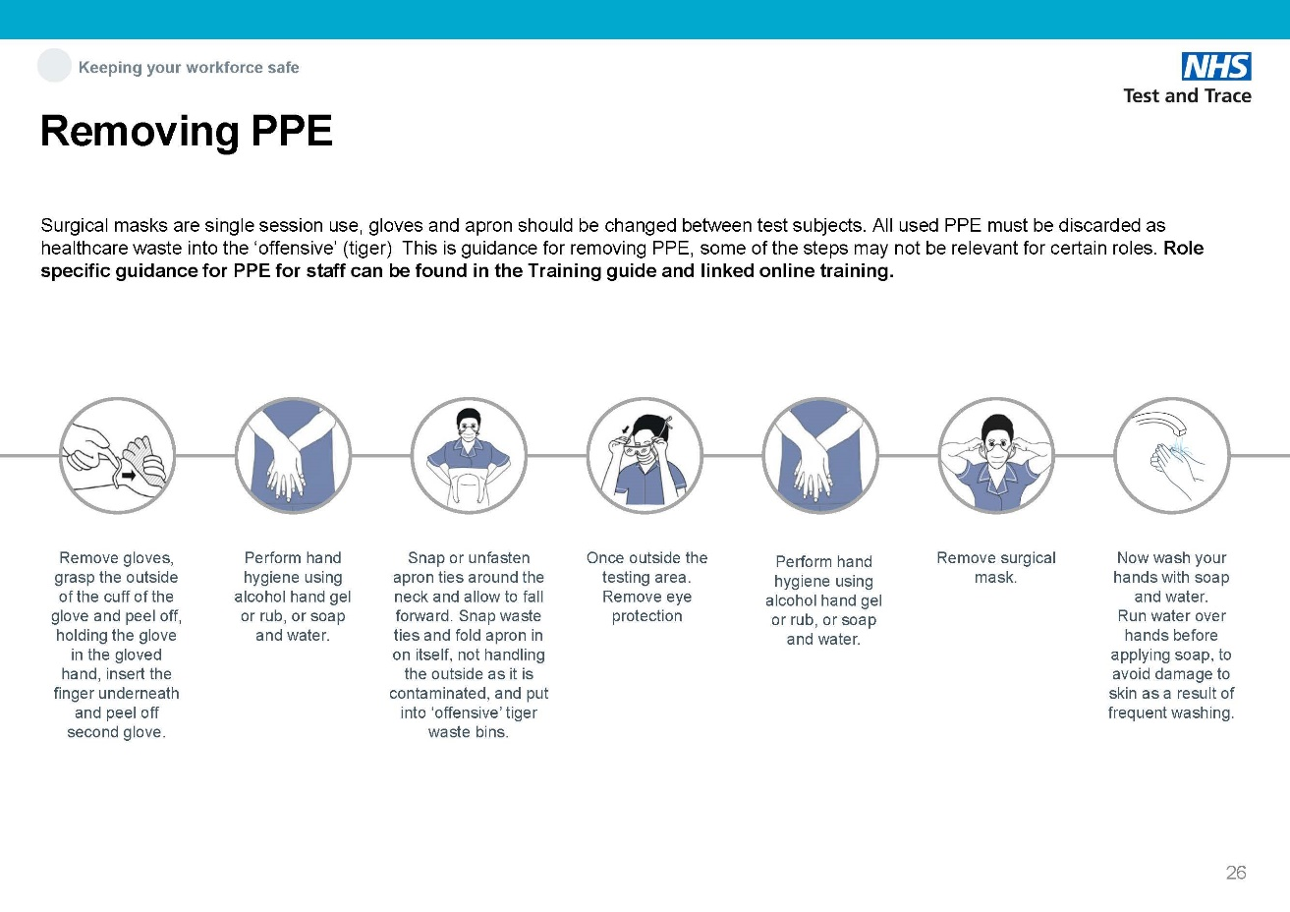

- Hands MUST be washed immediately after removing PPE
- The affected area must be secured and thoroughly cleaned and disinfected using appropriate cleaning products before being accessed by anyone else.
- Continue to ventilate the space after using.
- Thoroughly wash all your clothing as soon as you arrive home. Avoid shaking clothing before placing in the washing machine.
- Vehicles should be decontaminated frequently. Sanitiser should be used to clean down seats, gear sticks, steering wheel, door handles, etc.

Policies and Procedures Staff Signature List

Name of Document:

COVID-19 - COVID Prevention (Schools) Safe System of Work

I acknowledge that I have read and understood the information relating to the above document and I confirm that I will work in accordance with this; informing my line manager should I require further clarification or training on this subject.

Staff Member | Signature | Date

